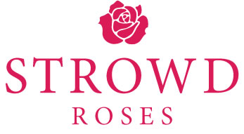
First Time Grant Application
PLEASE READ THE FUNDING GUIDELINES BEFORE COMPLETING THIS FORM.
APPLICANTS MUST COMPLETE THEIR REQUEST ON THIS FORM. PLEASE DO NOT SIMPLY REFERENCE ATTACHED MATERIALS. Supplemental materials are not to exceed two pages.

Name of Organization:
Amount Requested:
Name of Contact Person:
Title of Contact Person:
Street Address / P.O. Box:
City:
Zip Code:
E-mail address:
Telephone Number:
Fax Number:
Web Site:
- Does the organization have tax-exempt status?:
- If yes, please include a copy of the IRS determination letter.
- If no, and you operate or are applying under the auspices of another tax-exempt organization, please specify the organization and include a copy of their IRS determination letter.

- Describe briefly the mission and outcomes of the organization and the population it serves. Please indicate the number and percentage of the total population served BY THE ORGANIZATION who are Chapel Hill-Carrboro residents. (Word limit: 450 words, single spaced)

- Please describe what other organizations (if any) have similar missions that serve the Chapel Hill-Carrboro community and how you collaborate with them (if at all). (Word limit: 100 words, single spaced)

- Describe briefly the qualitative and quantitative goals and projected outcomes of the specific project or purpose for which you are requesting funding. Please indicate the projected number and percentage of Chapel Hill-Carrboro residents who would be served BY THE GRANT FUNDS. (Word limit: 450 words)

- Please provide a budget that includes a statement of all prospective sources of income for the program or project for which you are applying for funds. If the organization administers programs or projects other than that for which it seeks Strowd Roses funding, please include a copy of the organization's overall operating budget.

- Which of the following most closely reflects the primary broad issue area addressed through your grant request: Animals, Arts and Culture, Education and Literacy, Environment, Health, Latino Services, Senior Services, Youth Services, or General Welfare?

- Please list your board members.

